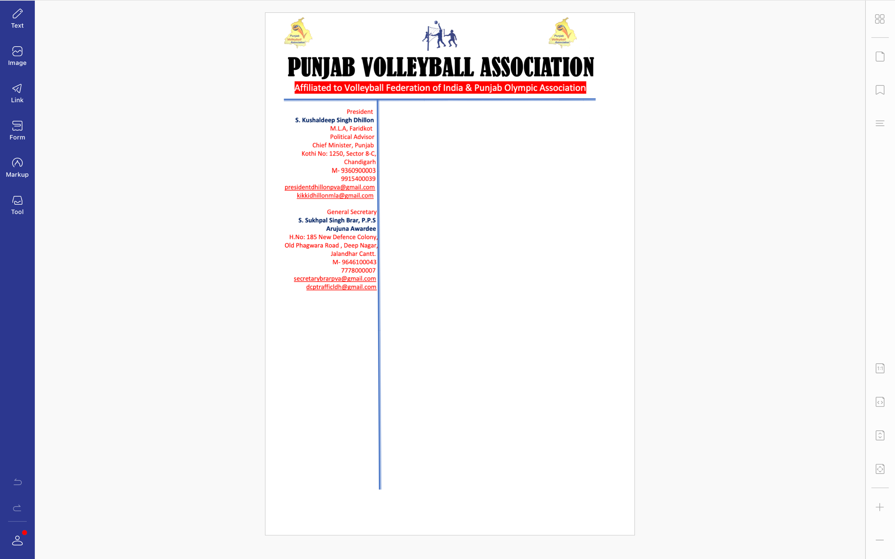/Spl-2(a)/2009 Dated : 20-09-2021

**Ref. PVA/BRAR/2021/Spl.-(2)/2009** Dated: 20-09-2021

v`l:

sports fwierYktr

pMjwb Kyf ivBwg

cMfIgVH

ivSw: sInIAr styt vwlIbwl cYNpIAniSp (mrd Aqy AorqW) iv`c kocz swihbwn (rYPrI) dI ifaUtI sbMDI

auprokq ivSy dy sbMD iv`c Awp jI nUM bynqI kIqI jWdI hY ik sInIAr styt vwlIbwl cYNpIAniSp (mrd Aqy AorqW) jo ik izlwH vwlIbwl AYsosIeySn, PrIdkot v``loN imqI 1,2 Aqy 3 AkqUbr, 2021 idn Sukrvwr, SnIvwr Aqy AYqvwr nUM PrIdkot ivKy krvweI jw rhI hY [ ies tUrnwmYNt nUM sucwrU FMg nwl krvwaux sbMDI hyT ilKy koc swihbwn jI dI ifaUtI qy Byjx dI ikrpwlqw kIqI jwvy jI qW jo styt cYNpIAniSp sucwrU FMg nwl krvweI jw sky[

1. Ajy nwgr vwlIbwl koc, sMgrUr
2. hrpRIq isMG vwlIbwl koc, biTMfw
3. suKrwj isMG vwlIbwl koc, PrIdkot
4. hrpRIq kOr vwlIbwl koc, sMgrUr
5. rwjivMdr kOr vwlIbwl koc, SRI AMimRqsr swihb
6. plivMdr kOr vwlIbwl koc, jlMDr
7. gunjIq kOr vwlIbwl koc, luiDAwxw
8. gurpRIq isMG vwlIbwl koc, mwnsw
9. jgjIq isMG vwlIbwl koc,pTwnkot
10. AimRqpwl isMG vwlIbwl koc, jlMDr
11. sunIl kumwr vwlIbwl koc, luiDAwxw

DMnvwd sihq

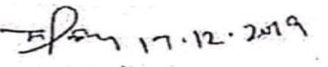

suKpwl isMG brwV, Arujnw AvwrfI

jnrl sk`qr

pMjwb vwlIbwl AYsoSIeySn